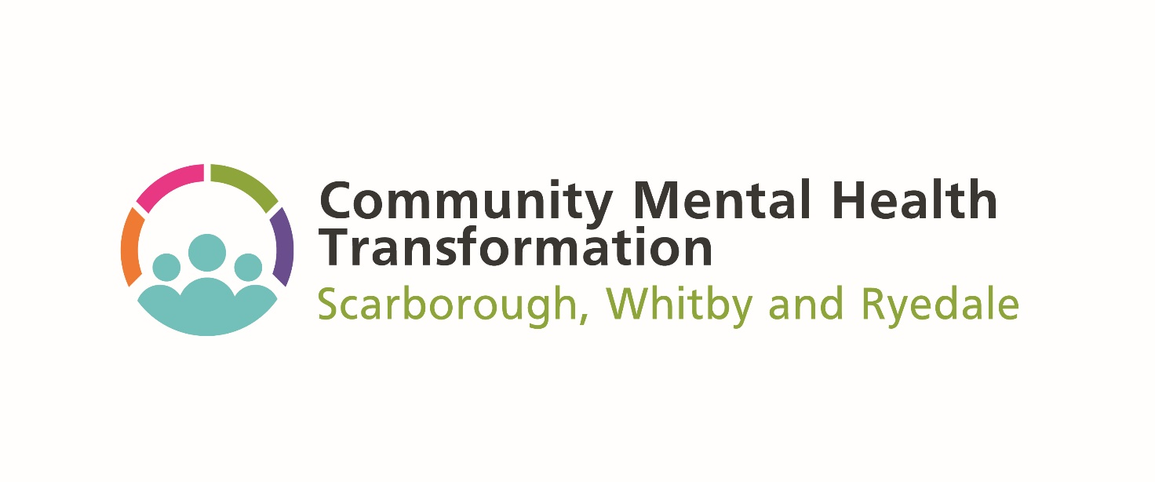

**Access and Connect Grant Fund 2023/2024**

**Micro-Grants**

**Application Form**

**SECTION 1: TELL US ABOUT YOU OR YOUR ORGANISATION**

|  |  |  |
| --- | --- | --- |
| Q1. Name of your organisation: |  | |
| Q2. Name of main contact: |  | |
| Q3. Address: |  | |
| Telephone: |  | |
| Email: |  | |
| Q4. Project name: |  | |
| Q5. Please give a brief overview of you or your organisation and the main activities and / or services you provide. (Max 200 words) | | |
|  | | |
| Q6. What is the status of your organisation? | | |
| **Organisation Structure** | | **Registration / reference number (if applicable)** |
| Registered Charity | |  |
| Community Interest Company (CIC) | |  |
| Constituted voluntary or community group | |  |
| Town or Parish Council | |  |
| Faith Group | |  |
| Un-constituted community group | |  |
| Micro-business or sole trader  *(Please describe)* | |  |
| Q7. How long has your organisation been established? | |  |

**SECTION 2: TELL US ABOUT YOUR PROJECT**

|  |
| --- |
| Q8. Please tell us about your project and how this supports the ambitions of the funding  (see guidance).  (Max 1000 words) |
|  |

|  |  |  |
| --- | --- | --- |
| Q9. Please tell us about anyone else you are working with to develop and deliver this project?  For example, partners within the voluntary sector, Local Authority, NHS, and people with lived experience, and/or service user or carer groups (Max 200 words). | | |
|  | | |
| Q10. Please tell us the reasons why you think your idea should be awarded a grant from this fund.  (Max 200 words) | | |
|  | | |
| Q11a. Which of the Scarborough Whitby Ryedale outcomes will your project contribute to?  **Tick all that apply.** | | |
| Provision and maintenance of quality and consistent information about local services, their capacity, and how and where to access or introduce to them. | |  |
| Expanded range of locally accessible, co-created services which enable people with SMI to ‘wait well’ whilst accessing longer-term support. | |  |
| Develop greater awareness within the wider community of the needs of people with SMI, including being more confident in speaking with them and offering initial support or help accessing services. Identifying and meeting different communication needs to achieve this. | |  |
| Diversely advertised access to information about services - and how they can meet peoples’ needs - within community settings that are closer to where they live and work. | |  |
| Support and recognition for unpaid and/or unrecognised carers, resulting in improved outcomes for those they support, and reducing negative impact on their own wellbeing. | |  |
| Improved community based therapeutic services offer that enables greater equity of access. | |  |
| Provision of local access to a trusted person who can help people with SMI navigate and benefit from services. | |  |
| Develop an improved understanding of the needs of service users/carers, staff and volunteers, in relation to the development of a Community Mental Health ‘Hub’. | |  |
| Q11b. Which of the localities will the project take place? See guidance for more details.  [Primary Care Networks - NHS North Yorkshire CCG](https://northyorkshireccg.nhs.uk/about/member-gp-practices/primary-care-networks/) | | |
| Locality 1: Scarborough Core Primary Care Network Area | | |
| Locality 2: Filey and Scarborough PCN Area | | |
| Locality 3: North Riding PCN Area | | |
| Locality 4: Whitby, Coast and Moors PCN Area | | |
| Q12a. Total cost of your project. | **£** | |
| Q12b. Expenditure breakdown |  | |
| Q13. How much grant would you like to apply for from the fund? | **£** | |

|  |  |
| --- | --- |
| **Supporting Information** | **Tick** |
| Constitution / Memorandum and Articles of Association of Organisation (VCSE organisations) |  |
| A signed copy of latest audited accounts |  |
| **Please detail the insurance cover (i.e. public liability and / or buildings and contents) that you or your organisation has in place that is relevant to this application.** | |
|  | |
| **Please confirm that the appropriate Disclosure and Barring Service (DBS) checks have been carried out on those staff working with and / or supporting proposed beneficiaries.** | |
| Yes  No | |
| **Please confirm that you have the relevant policies and procedures in place to deliver this project; for example, Safeguarding, Equality and Diversity, Lone Working.** | |
| Yes  No | |
| **Please confirm that your processes are GDPR compliant.** | |
| Yes  No | |
| **If there is a reason why you have been unable to supply any of the information outlined in Section 3, please detail why in the box below.** | |
|  | |

|  |  |  |
| --- | --- | --- |
| **Signature of Applicant:** | |  |
| **Date:** | |  |
| ***Data Protection:*** | | |
| *All the information you enter on this form will be stored and held in accordance with relevant data protection legislation and used by NYC and its agents for the purpose of analysing, recording and publicising grants.* | | |
|  | *Please check the box to indicate you have read this statement and agree to your data being used for these purposes.* | |
| *If you do not agree to this, please write stating this fact to the address below.*  *Stronger Communities Team, North Yorkshire Council, County Hall), Northallerton, DL7 8AD*  *North Yorkshire Council’s Stronger Communities Team administer this grant funding on behalf of the Humber and North Yorkshire Integrated Care Board.* | | |

**Thank you for your application, a member of the team will be in touch with you soon to update on the outcome.**